NIHR Manchester BRC Overview
Manchester BRC’s vision is to drive personalised health and care for all. We deliver innovative translational research that addresses important health and care priorities across Greater Manchester, Lancashire and South Cumbria, transforming disease prevention and management, at pace and scale and with equity in our integrated, devolved health and care system. Patients, public and practitioners are at the heart of all we do, and we support an inclusive and diverse research workforce with a Team Science/Research approach. Manchester BRC aims to be a national exemplar of how an integrated regional system can deliver innovations that serve the needs of the whole population and be the collaborator of choice for strategic research funders, industry partners and investors.

NIHR Manchester BRC is hosted by Manchester University NHS Foundation Trust in partnership with The University of Manchester. Additional NHS Partners are:

- Blackpool Teaching Hospitals NHS Foundation Trust
- The Christie NHS Foundation Trust
- Greater Manchester Mental Health NHS Foundation Trust
- Lancashire Teaching Hospitals NHS Foundation Trust
- Northern Care Alliance NHS Foundation Trust

MFT and UoM work together within Health Innovation Manchester (HInM) and co-Chair the GM NIHR Oversight Board that guarantees a coherent strategy to accelerate research and innovation into improved clinical care across NIHR infrastructure. Our key GM partner Trusts (Northern Care Alliance, Greater Manchester Mental Health and The Christie) play an active role within this infrastructure as part of the ‘One Greater Manchester’ approach. Key clinical research hubs to support our BRC are provided by partner Trusts including GMMH (3rd highest recruiting mental health Trust in England) and NCA (rheumatology, dermatology and neurosciences and nephrology). In addition, The Christie hosts the new Paterson Institute for Cancer Research (£150m); a dynamic interface for researchers co-located with clinical services. Blackpool and Lancashire Teaching Hospital Foundation Trusts (BTH, LTHTr) further widen this model across our region and provide additional expertise improving access to translational research for diverse populations with high disease burdens and inequities.

NIHR Manchester BRC is one of twenty BRCs funded from 1 December 2022 until 31 March 2028 and was awarded £64.1million. This is more than double the previous BRC award (£28.5million from 2017-22) and the NIHR Manchester BRC is the largest BRC outside of the South East of England.

NIHR Manchester BRC Aims

- Embed early translational research further into our communities and localities in GM, Lancashire and South Cumbria by deepening the meaningful involvement of patients, public and civic partners, to understand and prioritise health and care needs, particularly in the context of high deprivation.
- Build a unique national powerhouse for innovation by combining the world-leading discovery and translational science capabilities of our partnership with a strong research culture centred on a committed, diverse and inclusive workforce, to narrow health inequities across our urban, rural and coastal settings.
- Accelerate at scale, the impact of our research through our mature and integrated innovation pipeline, to achieve measurable improvements in health and wellbeing across all sections of society in our region and beyond.

Management and Governance Arrangements
Manchester BRC is hosted by Manchester University NHS Foundation Trust (MFT), in partnership with The University of Manchester (UoM). MFT is the legal host for our Academic Health Science System - Health Innovation Manchester (HInM) – and established the Greater Manchester NIHR Oversight Board which brings together all hosted NIHR infrastructure to ensure our research and innovation capabilities align and provide excellence and value for money.
The BRC Governance Board holds the BRC’s leadership to account for delivery of overall strategic objectives and financial performance. Significant changes to the BRC budget and/or Themes require Governance Board approval. The BRC Governance Board, attended by the BRC Director, is chaired by the MFT Group Chief Executive. Membership includes senior representatives from UoM (Dean of the Faculty of Biology, Medicine and Health), senor representatives from across the BRC NHS Trust partners, the Executive Chair of Health Innovation Manchester, the Medicines Discovery Catapult CEO, two public/patient partners, MFT/UoM EDI Leads and the Chair of our International Scientific Advisory Board (ISAB).
The BRC Director chairs the BRC Strategic Executive that includes Cluster Board Chairs, Theme Leads, Leads for our Inclusive Research Infrastructure and Strategic Core Delivery areas (Figure 1) as well as public/patient partners, NIHR infrastructure leads, communications and children/young adults research. It drives delivery of a cohesive scientific strategy across all our partners, promotes and invests in cross-Theme scientific programmes and champions equal and inclusive support of BRC teams working with a range of stakeholders including other BRCs, NIHR-funded programmes and external collaborators.
Our thirteen Themes (see below) are grouped into four Clusters each overseen by a Cluster Board. Membership of the Cluster Boards includes constituent Themes, Cluster Managers and a Theme Lead from each of the other three Clusters. Cluster Boards drive further integration across BRC Themes, use our established portfolio management systems to track progress of NIHR BRC majority-funded projects, and foster collaborations to facilitate multidisciplinary working. Theme Leads have responsibility for Theme management and progress towards delivery of strategy, SMART objectives and financial performance. Each co-Theme Lead will assume oversight for the Theme on assigned strategic activities (PPIEP, partnerships, EDI, capacity building).
Our International Scientific Advisory Board critically assesses and advises on scientific strategy, ambitions and progress. Chaired by Professor Dermot Kelleher (Dean of the Faculty of Medicine, University of British Columbia), ISAB members are clinical, academic and industrial experts in BRC research areas. The ISAB provides annual independent feedback to ensure that we remain internationally leading. An ISAB-led formal ‘mid-term’ review (24 months) will advise on prioritisation and deprioritisation of BRC programmes.
Figure 1 – Governance Arrangements
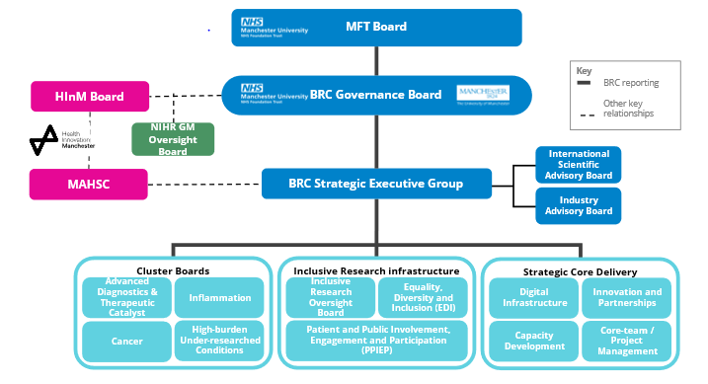
Management of funding and research prioritisation
The BRC Director is responsible for and has authority over BRC funding and is accountable for financial performance to the BRC Governance Board. Theme Leads manage their funding and Clusters support Themes to maximise value for money and patient benefit. Disinvestment/reinvestment recommendations are made to the BRC Strategic Executive Group for approval and are informed by project and Theme-level data on achieving milestones and objectives.
Supported by Manchester Academic Health Science Centre (MAHSC) and informed by our public and civic contributors, BRC investigators identify local, regional and national research and health priorities for their Themes and Clusters. Through this, alongside input from our ISAB, the Strategic Executive prioritises core challenges and unmet needs for strategic investment through funding calls that are targeted to involve at least two Clusters and a new collaborator in a partner Trust. The Strategic Executive supports acceleration of key projects towards late-stage development.
Key research areas

Our established core infrastructure supports scientific programmes aligned with MAHSC’s three grand challenges:

- Basic mechanisms of disease. Our discovery platforms and data science strengths drive deeper understanding of disease complexity, endotypes and multi-morbidity clusters, whilst integrating inclusive research principles, to understand how social factors influence biology in common disease processes.
- Prevention and early detection. Building on our international leadership (International Alliance for Cancer Early Detection), and prioritising deprived communities and localities, we will translate insights across all Themes to predict and prevent disease and co-morbidities. Co-production with local, regional and international industry leaders in integrated diagnostics will provide a global outlet for innovations.
- Person-centred therapies, interventions and care pathways. We are in the vanguard of the discovery and early development of next generation therapies, including advanced materials and nanomedicine and cell and gene therapies. With the Christabel Pankhurst Institute (digital technology and advanced materials) technology trial platforms, we will widen access to and participation in translational medicine.

Equality, diversity and inclusion (EDI) are central tenets of Manchester BRC built on our world-leading track-record of social responsibility. We have established an Inclusive Research Oversight Board (IROB) that includes patients, citizens, public health, methodologists and GM-ICS. Patient and public voices from across our diverse region co-produced our vision and aims and are embedded into our scientific and governance structures. Through meaningful engagement, we will understand the complex and diverse experience and perspectives of our communities, promoting a more health research confident population.

To address patient need and respond with agility to changing circumstance, our academic and workforce training programmes will embrace the diversity of people, skills, values and behaviours required for Team Science in biomedical research. We will support an inclusive workforce through delivery of our ambitious EDI strategy, taking bold actions to address under-representation and tackle systemic bias.

Outline of Clusters and Themes

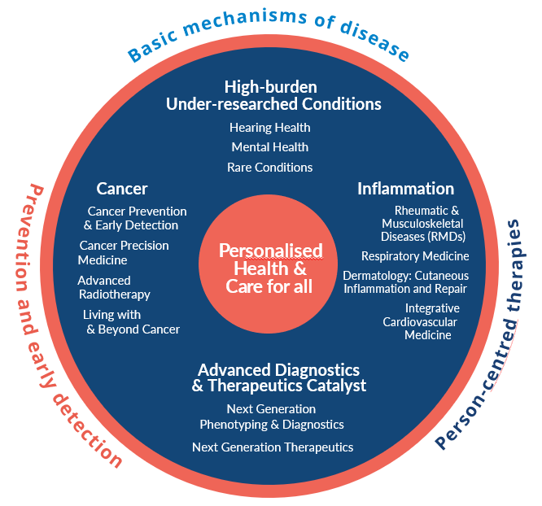

All thirteen BRC Themes have internationally-leading research strengths and address major unmet clinical needs. Themes collaborate in four Clusters to maximise cohesion and encompass a wider geographical reach and mission.

Advanced Diagnostics & Therapeutics Catalyst Cluster
- Next Generation Phenotyping and Diagnostics
- Next Generation Therapeutics

This Cluster harnesses our systematic discovery, data science and early phase trials capabilities to provide a deeper understanding of disease mechanisms, including how inequalities and social factors impact biological processes. It provides a platform to provide early proof of concept for our novel therapeutics pipeline and accelerates new diagnostics and precision therapies towards later stage development.

Inflammation
- Rheumatic and Musculoskeletal Disease (RMD)
- Respiratory Medicine
- Dermatology: Cutaneous Disorders and Wound Healing
- Integrative Cardiovascular Medicine

We have basic science excellence in genomics, immunology and inflammation and fibrosis. This Cluster addresses several of the most common causes of death and disability in our region and nationally in which prognosis is strongly influenced by deprivation and adverse social determinants. Themes deepen understanding of the common and individual processes driving disease evolution, co-morbidities and therapeutic responses and translate these to precision trials in patients across the life course to reduce morbidity and mortality.

Cancer
- Cancer Prevention and Early Detection
- Cancer Precision Medicine
- Advanced Radiotherapy
- Living with and Beyond Cancer

Manchester is one of four CRUK Major Centres. This Cluster is addressing emerging challenges and opportunities to improve the lives of all cancer patients. It provides a comprehensive approach to the whole patient/person journey by addressing prevention and early detection, key modes of cancer therapies (Advanced Radiotherapy and Precision Medicine) and addressing MLTCs in cancer survivors, all to provide new trials for complex patients and reduce the overall impact of cancer.

High-burden Under-researched Conditions
- Hearing Health
- Mental Health
- Rare Conditions.

A national priority is to address conditions that cause significant morbidity and disability, but which traditionally have less per-patient research funding. Across this Cluster are examples of unmet need for people with protected characteristics and hidden disabilities including neurodiversity. This Cluster focuses on prevention and early diagnosis to reduce long-term disease burden and use novel approaches including gene therapies, digital interventions and devices to transform the lives of patients.

Operational Delivery of overall objectives

The BRC Operations Director coordinates the BRC Core Team comprising specialist Theme and Project Managers driving delivery across themes and strategic areas including Core Funding, Capacity Building, Industry and Partnerships, Performance and Data management to ensure consistent and aligned practice across Manchester BRC. Our Core Team supports Themes, Clusters and strategic areas to monitor progress against SMART objectives, providing regular assessment of scientific progress and financial performance. If required further decision-making is escalated through Clusters to the Strategic Executive (see Governance).

Capacity Building
The BRC is committed to supporting and developing our student population and workforce and building experimental medicine capacity. Our Capacity Building Lead sits on our Strategic Executive and leads a multidisciplinary Capacity and Training Group representing key BRC professional and methodological groups. The Capacity Building team co-ordinates strategic investment in training and capacity building and monitors delivery. Working with our EDI leads, NHS/University partners and the NIHR Academy the BRC focuses on supporting diverse talent and equality of access whilst widening training opportunities across Greater Manchester, Lancashire and South Cumbria localities.
Intellectual Property (IP) and Commercialisation
Manchester BRC benefits from a comprehensive IP and commercialisation support infrastructure across the MFT-UoM partnership. This includes joint Strategic Oversight and Operational groups across UoM and partner Trusts, a Memorandum of Understanding around jointly developed IP, and agreed processes for IP capture and commercial assessment. Annual audits of our portfolio with the NIHR IP Team enables identification of commercially attractive research for further support and investment. The BRC Industry Lead is a member of our Strategic Executive and our Industry Team, in collaboration with UoM and partner Trusts, ensures effective management of our commercial partners across organisations.
Strategic core funding
Manchester BRC invests in our workforce through funding and placement schemes, alongside bespoke opportunities to support career progression. We also hold regular pump priming funding calls to invest in areas of strategic priority and also horizon scan to support new and emerging areas of potential.
Communications
The Manchester BRC communications team reports to the Strategic Executive and is part of a GM-wide communications network co-ordinated through local and regional partners. We prioritise accessible communications in a variety of formats and to a range of audiences. We have well-established links to NIHR and other national funding partners, we publish regular newsletters and blogs to key stakeholders, and maintain an active social media presence (including X, LinkedIn) with the NIHR Manchester BRC website a primary source of information and evidence of our impact. Peer-review publications are, wherever possible made Open Access and we link with Policy@Manchester to widen impact for our key academic outputs.
Impact
Capturing the impact of the work of the BRC is a priority. Not only is this a condition of our funding, but it keeps the focus on our patients and communities at the heart of all we do.
For the NIHR, research impact is about making a meaningful difference to people’s lives through the research it funds and supports, making a difference to wider society and effecting meaningful change i.e. an effect or benefit.
We submit a range of impact case studies to the NIHR, sharing these across our communication channels and record planned and achieved impact across our themes and programmes regularly to amplify and support progression through the translational pathway within the ecosystem.

Strategic Partners

NIHR Manchester BRC is at the heart of a city-region with an economic vision to generate £7bn of inward investment and 100,000 jobs to deliver a fairer, greener and more productive local economy. Innovation GM will drive this vision and establish Innovation Zones (including Innovation District Manchester, £1.5bn). Through our Industry Advisory Board and partnerships team, we are expanding collaboration and co-development opportunities by attracting and embedding pharma and SMEs into our work. We actively seek additional partnerships to optimise commercialisation and further develop our research capacity.

Our long-standing partnerships with charities enable us to influence and inform strategy and attract investment to accelerate translation (e.g. Wellcome Trust Translational Partnership Award), build capacity (CRUK and Kennedy Trust (inflammation) MB-PhD programmes), and support the work of Clusters (CRUK Major Centre, CRUK-MI, the Paterson Institute and Versus Arthritis Centres)

We continue to expand our links with other BRCs and NIHR initiatives including NIHR BioResource and NIHR Translational Research Collaborations (TRCs).

We have extended our reach across the UK with Queen’s University Belfast, in several areas of research. Globally, our work with Kenya brings innovations in cancer (Radiotherapy, Prevention and Early Detection) to the Global South to support sustainable health and care solutions and International Development.

